 | Assignment No. 01  SEMESTER SPRING 2021  CS403- Database Management System | Total Marks: 20  Due Date: 05/24/2021
Solution

NAME: TAMKEEN SAJJAD
ID: MC200400003

Course: MIT

- Draw the context level diagram.
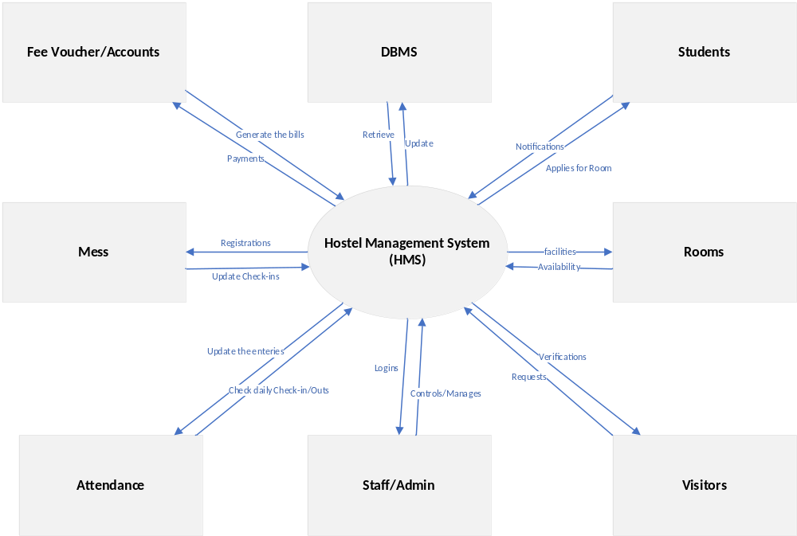
- Draw the level 0 DFD.
